10 Billion to 22 billion in 2025, value 14 Trillion in 10 years.

Slides 1 The Internet of Things

is a shorthand way of describing a globally interconnected continuum of devices and objects interacting with the physical environment, people and each other

Combination of Techs + Fundings + Business Hype

Techs Micro-Sensors, Tags, Energy efficient communication, Micro-Computing, Cloud Computing, Open operating system.

A lot of fundings

Business opportunities Components, Smart objects, Systems, Networks service provider, Application Service Providers.

Challenges Naming and Addressing, Power management, Things to cloud, Miniaturization, Big Data Analytics, Semantic technologies, Virtualization, Privacy/security, Heterogeneity.

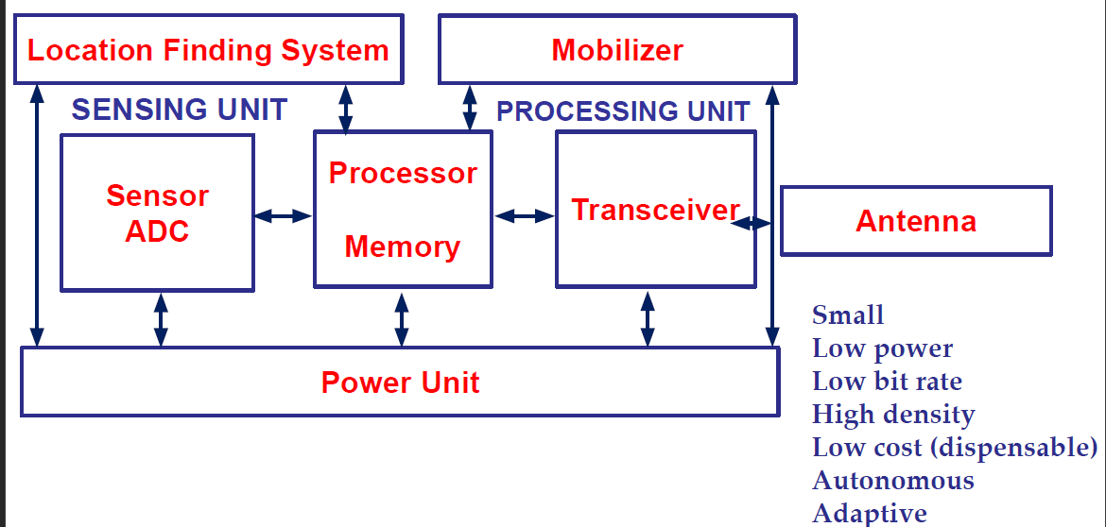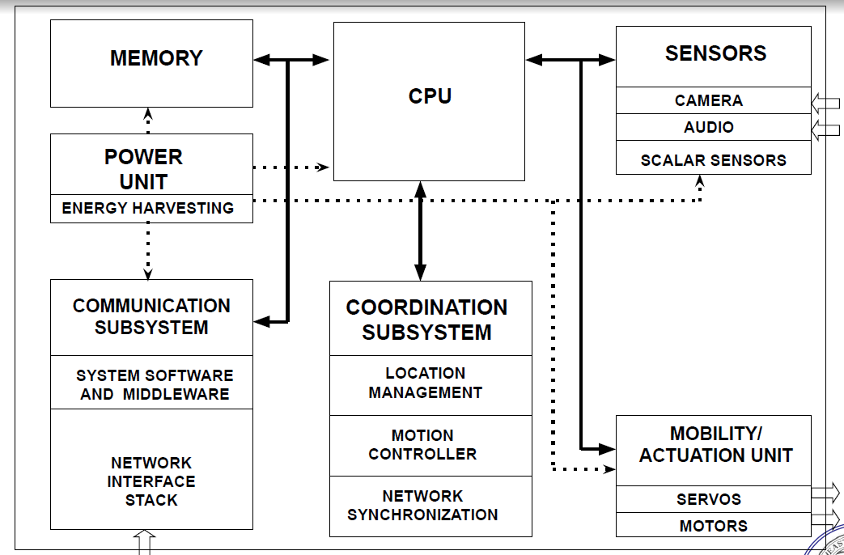

**Infrastructure-less wireless networks** Infrastructure **based:** 4G/5G network, base stations connected to a wired backbone network.

No infrastructure is available / Too expensive to set up / No time to set up

Factory floor automation, Disaster recovery, Vehicular communication

**Ad Hoc** Networks **(MANET)**

Without central infrastructure, participants must organize themselves into a network (self-organization)

**Challenges**: Finding route, Discovering neighboring devices, Medium access control

Multi-hop Wireless Networks: Peers outside immediate communication range.

**Adaptive Protocols**: Mobility changes neighborhood relationship, Routes must be reconfigured adaptively. Complicated by scale.

**Wireless Sensor Networks (WSN)**

Examples: Disaster relief operations, Biodiversity mapping, Intelligent buildings

**Roles of participants** in WSN: Sources of data, Sinks of data, Actors/actuators

WSN application types: Event detection, Event classification, Periodic measurement, Function approximation, Edge detection, Tracking

Deployment options: Random deployment, Regular deployment, Mobile sensor nodes.

**Characteristics** of WSN: Scalability, Wide range of densities, Limited resources for each device, Mostly static topology,

More Characteristics: Service in WSN(Communication is triggered by events), Quality of service(Traditional QoS metrics does not apply), Fault tolerance(Robust against node failure)

Life time, Programmability, Maintainability.

Typical Adopted Mechanisms: Multi-hop wireless communication, Energy-efficient operation, Self-configuration, Collaboration & in-network processing.

Mechanisms to Meet Requirements: Data Centric networking, Locality, Exploit tradeoffs.

**MANET vs WSN**

Application, equipment:

MANETs more powerful equipment assumed, high data rates, more resources.

Application-specific: WSNs depend much stronger on application specifics

Scale: WSN likely to be much larger

Energy: WSM tighter requirements, maintenance issues

Dependability/QoS: In WSN individual node may be dispensable, QoS vary from applications

Data-centric vs id-centric networking

Mobility

Enabling technologies for WSN: Cost reduction, Miniaturization, Energy scavenging

Command, Control, Communications, Computing, Intelligence, Surveillance, Reconnaissance, Targeting**. (C4ISRT)**

Great Duck island, Firebug, Health cares, CodeBlue

Underground Sensor Networks**(UGSN)**

Underwater Sensor Networks

Wireless Sensor and Actor Networks: Needs for automation

WSAN Applications: Transport and parking solutions, Environmental Applications, Microclimate control in buildings, Agriculture Applications, Distributed Robotics

**WSAN vs WSN:**

Real-time requirement for Timely Actions: Rapidly respond to input(fire detect),

Heterogenous Node Deployment: Sensors: Densely deployed; Actors: Loosely deployed

Coordination Requirements: Sensor-Actor, Actor-Actor

Wireless Multimedia Sensor Networks

Networks of wirelessly interconnected devices that allow retrieving videos and audio streams, still images, and scalar sensor data.

Able to store, process in real-time correlate and fuse multimedia data originated from heterogeneous sources. Video/Audio Sensors.

**Moore’s law and bell’s law**, lots of interfaces and CPUs: Microcontroller, Digital Signal Processors, Application Specific IC, FPGA field programmable gate arrays

Front-end, Energy characteristics, Performance parameters (Modulation? Noise figure? Gain?)

**Transceiver** states: Transmit, Receive, Idle, Sleep (Recovery time and startup time)

Power Consumption: Communication, Data Processing, Sensing

Start time: depend on MAC protocol used.

To minimize power consumption, it’s desirable to have the transceiver in a sleep mode as soon as possible. **Trade-off**

A Simple Energy Model:

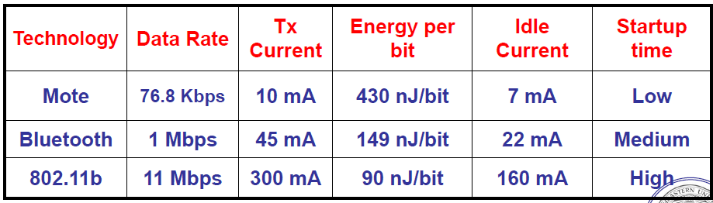

Focus on Radio-Frequency communications

Factors: Frequency band, Transmission power, Modulation scheme

Understanding the energy consumption of radio communications.

Transmitting data with radio waves: Amplitude Shift Keying, Frequency Shift Keying, Phase **Shift Keying IQ Data** analog modulation parameter arbitrary value, digital modulation parameter value from finite set

Problems: Carrier synchronization (frequency changes because of drift, temperature, aging), Bit synchronization(start/end), Frame synchronization (packet start/end).

Multi-carrier transmission: OFDM Time domain and Frequency domain

**Attenuation and Distortion**

Distortion: received is different from transmitted/ Sources: refection diffraction scattering doppler fading Attenuation: energy decreases when distance increases

Problems: none-line-of-sight paths, when calculating add a gaussian random variable, take obstacles into account.

Which model should we choose, depend on tradeoffs powers symbol rate

**Summary**: 1. Wireless radio communication introduces **many uncertainties**, unavoidable error will be a major challenge, deal with limited bandwidth in an energy-efficient manner.

**OOP programming**: providing **only essential information to the outside** and **hiding their background details**, no need to know, **internal implementation can change**

Encapsulation: data and function at same place

Inheritance: acquire all properties and behaviors of parent object

**Static binding and dynamic binding**, virtual. Polymorphism: able to change the behavior according to different variables.

Omnet++, accuracy and precision, confidence interval probability of the “true value” residing in the CI is 0.95

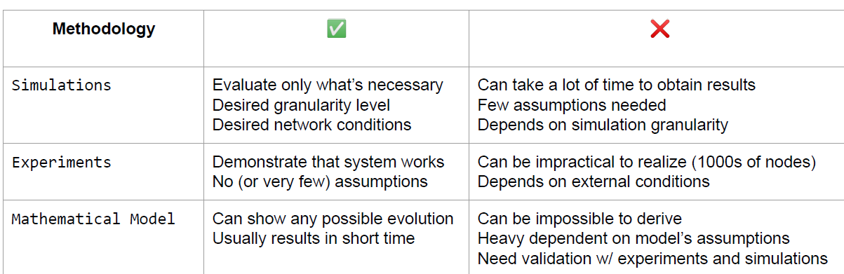

**MAC**

CSMA backoff exponential double IFS SIFS PIFS medium priority DIFS lowest priority

**Hidden** terminal: A->B C can’t hear C->D collide

**Exposed** terminal: B->A C heard C->D pause RTS CTS

Network allocation vector: NAV, receive RTS, NAV on, CTS has duration field to adjust NAV Both is free can send

**S-MAC**: periodic sleep and wake up, requires **periodic synchronization** with nodes clock drift, SYNC packets: node id next sleep time[SYNC RTS(data) SLEEP], carrier sense before transmission, broadcast without rts/cts. At light load, save a lot energy.

**Conclusion**: A static network, trades off **latency for energy**, Redundant data still sent, Increase collision rate due to sleep schedules.

**B-MAC**: A minimalistic approach, RTC CTS ACK at higher layer, use **CCA** and **LPL**, more flexible, Feedback to higher protocols.

**Noise Floor Estimation**: RSSI samples use formula to estimate, search for outliers, significantly low energy than the noise floor during sampling period. CCA->outlier found->busy

**Low Power Listening**: minimize listen cost, preamble length matches wakeup interval

S-MAC vs B-MAC: sync packets, multiple schedules, b much lower latency

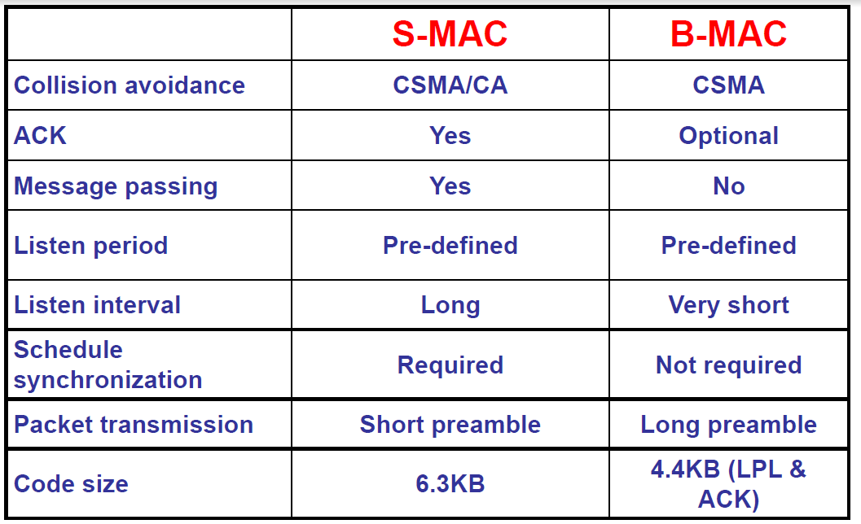

**802.15.4 MAC** Extremely low cost, Ease of installation, Reliable data transfer, Short range operation, Reasonable battery life

**Cons** of **TRAMA:**

Need space so store the schedules, space consumption;

Repeat changing schedule may be time consuming.

To use witch, depend on number of nodes, too small -> csma ; large -> trama

**TRAMA:** dynamic, adaptive to traffic patterns **Random access period**, **Schedule Access period**.

**Neighbor Protocol**: 2-hop neighbor information, no update->keep-alive or timeout

**Schedule Exchange Protocol**: 1-hop traffic information for scheduling. Calculate SCHED, pre-computes number of slots and hash winning slots, can release to other nodes. Schedule packets to announce, bitmap

**Adaptive Election Algorithm**: select transmitter receivers, other nodes low power mode.

**Limitations**: Complex election algorithm, overhead due to schedule exchange, Higher queuing delay, need memory to store schedule table, workload situation->TRAMA, duty circle->S-MAC, TRAMA has higher maximum throughout.

**Z-MAC**: none owner can steal time slots, using DRAND to calculate TDMA schedule in linear time to the maximum node degree in G. If Low contention level detected, take backoff To + random(Tno), owner has higher priority. If HCL detected (lost acks and repeated backoffs), Receive one-hop ecn, forward 2-hop ecn if on routing path. DRAND take lot of energy.

**Funneling-MAC**: decrease a lot near sink, localized control and react dynamically to network condition, an efficient scheduling protocol. Dynamically operated by the sink, Hybrid TDMA and CSMA.

**On demand beaconing**: dynamically drive the depth of intensity region, synchronize the nodes inside intensity region. Periodically broadcasts a beacon(same transmission power)

Receive beacon become f-node (in intensity region), sync with each other by initializing their clock, and passive registration to sink (increase transmission power to schedule more f-nodes or exceeds maximum reduce beacon power)

**Dynamic-depth tuning**, **Sink-oriented scheduling**.

**Error control**:

**Forward Error Control**: coding packets, change sequence to withstand burst errors, CRC check. **Constant overhead**, **not possible to adept to changing channel characteristics**.

**Automatic Repeat Request**: stop-and-wait, go-back-n, selective repeat over head only error

hybrid schemes

high error rate: FEC

neighborhood table